Jenkins Task-2

Task Description:
Create a simple script file and push it to repo. Create a project in Jenkins connected to your GitHub repository. When a commit is made to your repo, automatically build must get triggered from Jenkins and the output must be shared to me via email.

Create a simple script file:
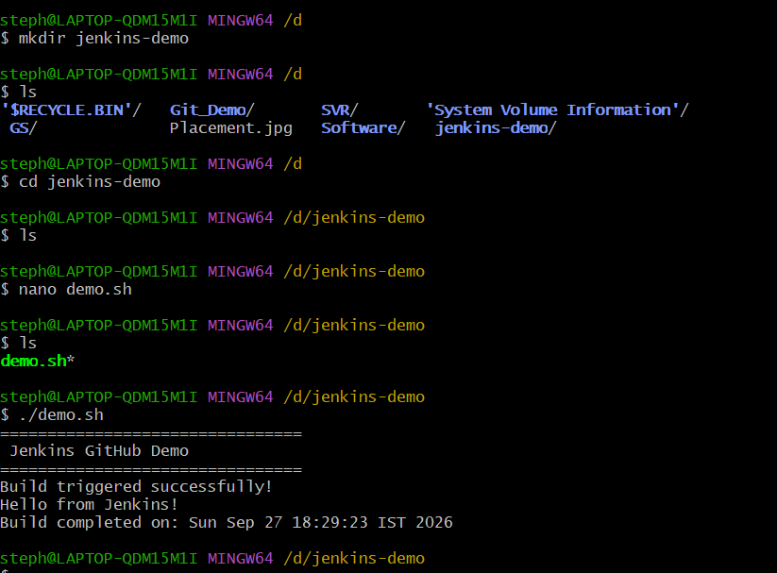
Create a GitHub repository and push the script to GitHub:
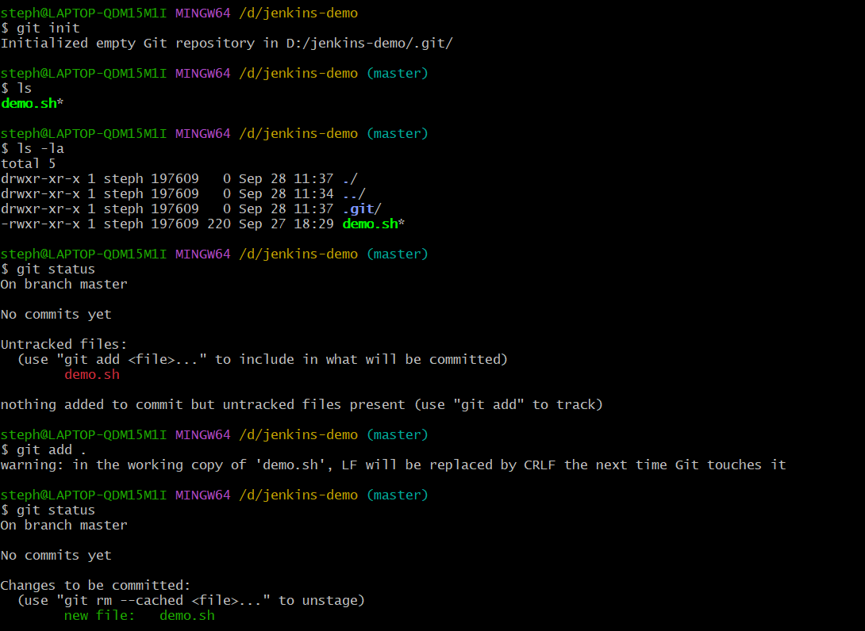
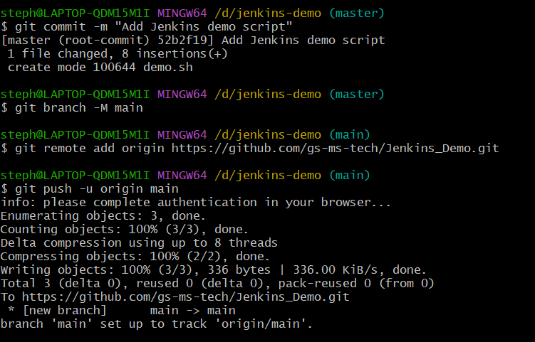
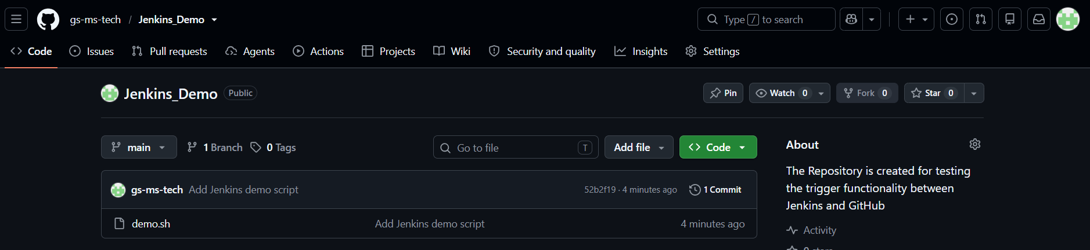
Install JDK & Jenkins plugins:
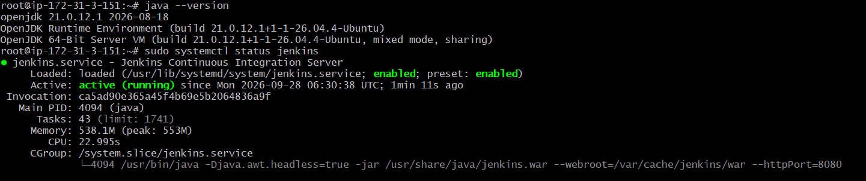
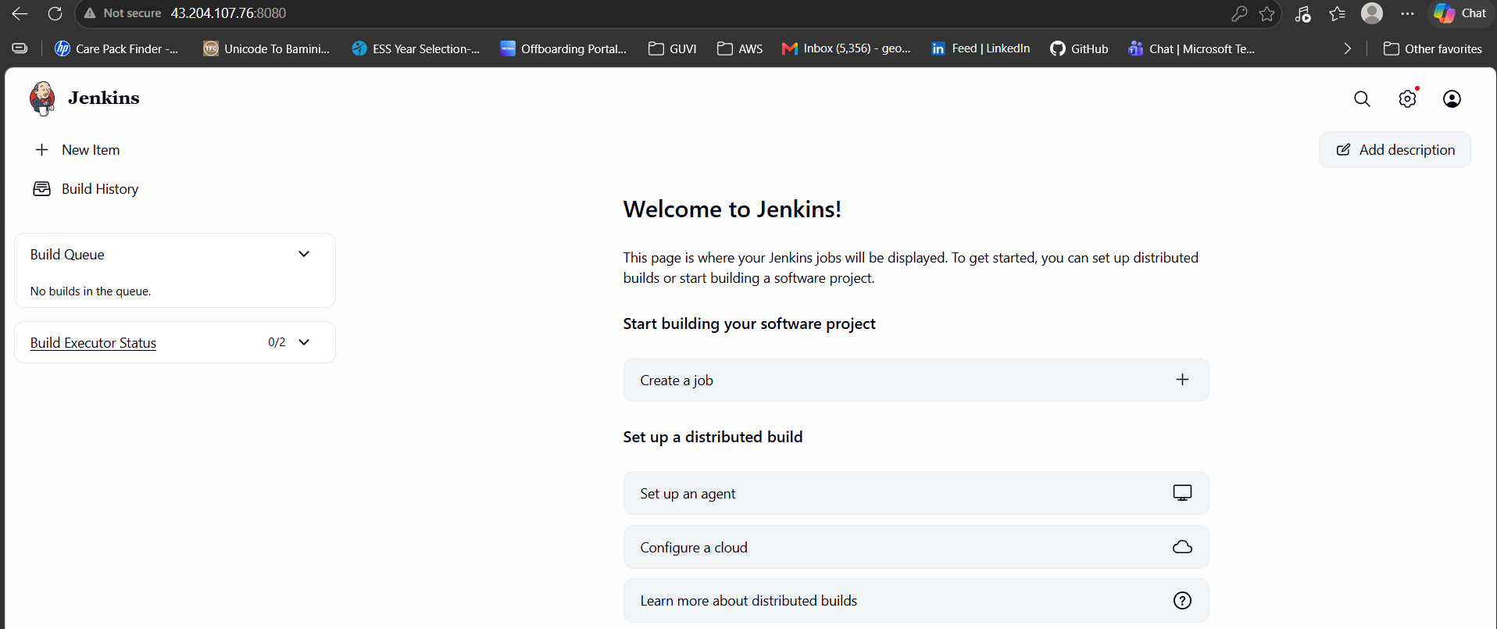

Configure Jenkins email notification as successful:
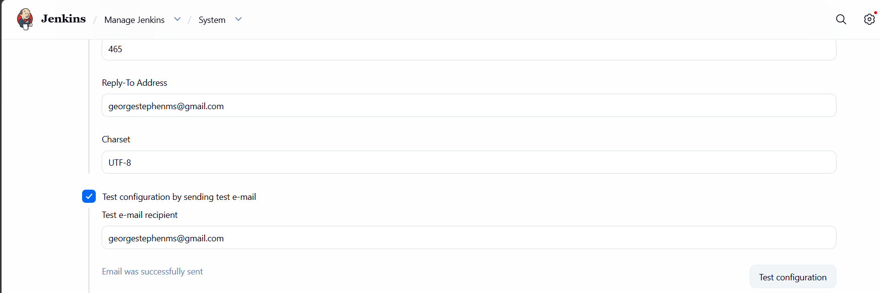

Create Jenkins pipeline project:
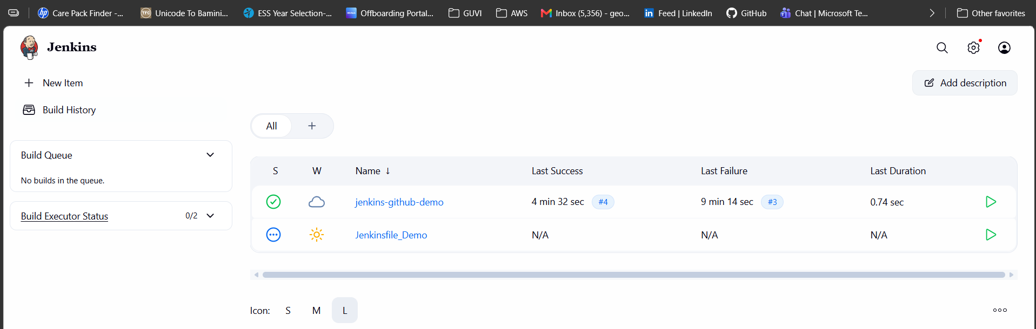
Connection created between Jenkins & GitHub:
Jenkins:
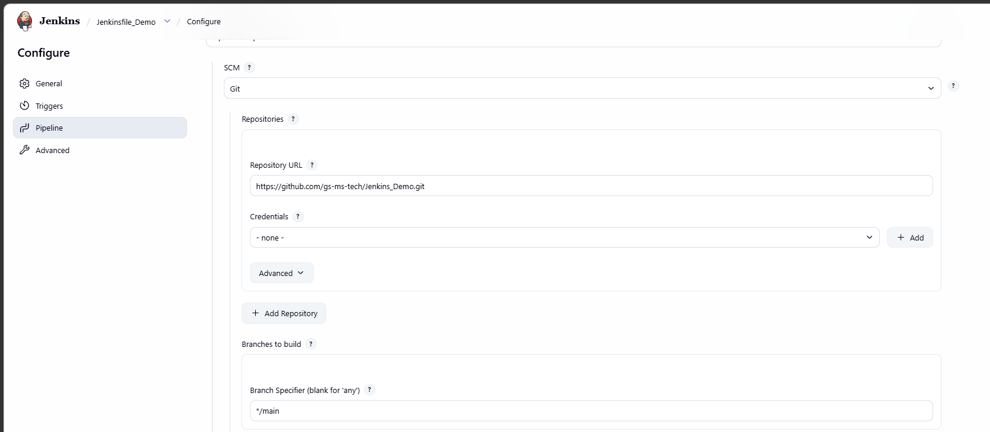

GitHub (Enable Webhooks):
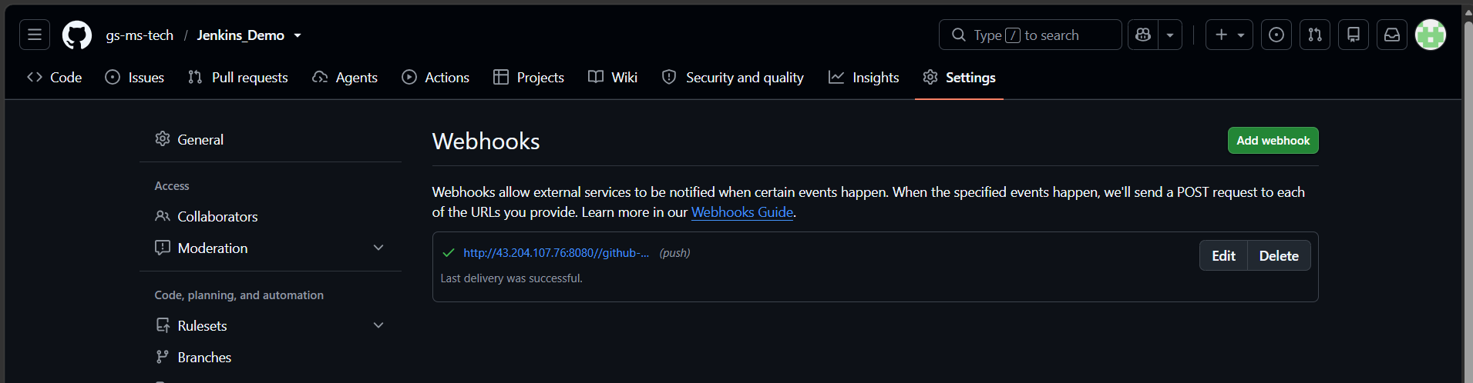

Create the Jenkinsfile:
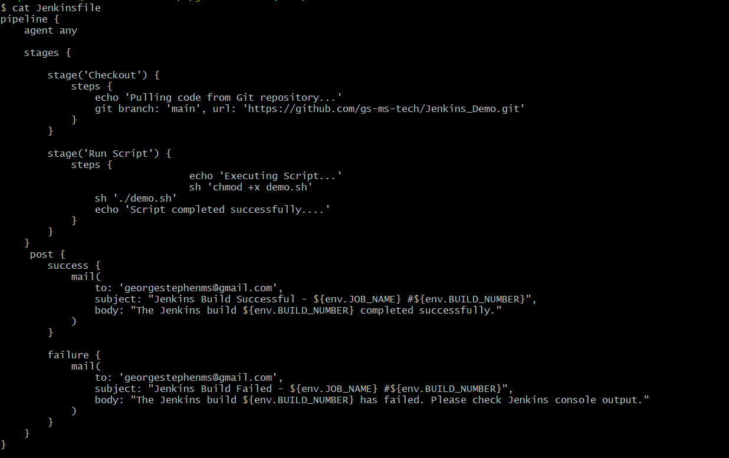

Push Jenkinsfile to GitHub remote repository:
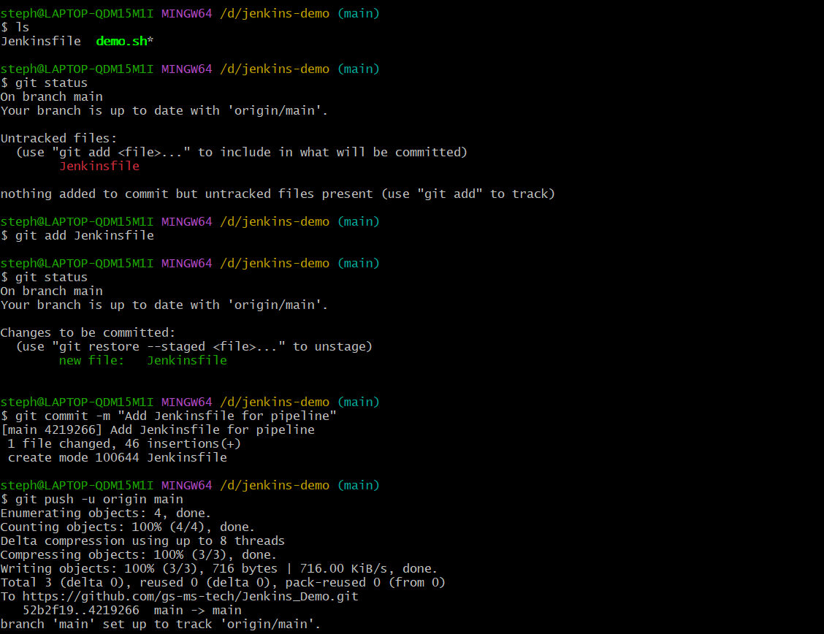
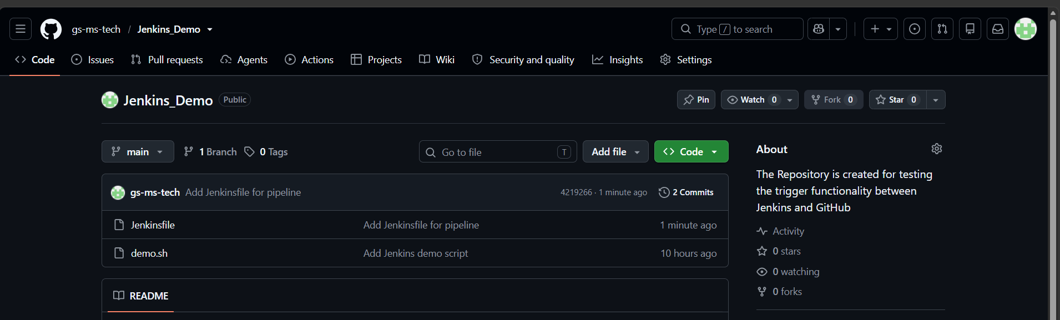
Test the complete process:
Once committed the code in GitHub Jenkins initiate the build automatically and sent mail as below.
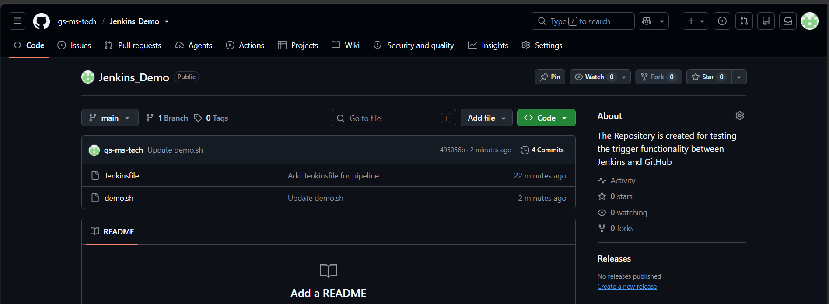

Once commit happened, automatically build start in Jenkins:
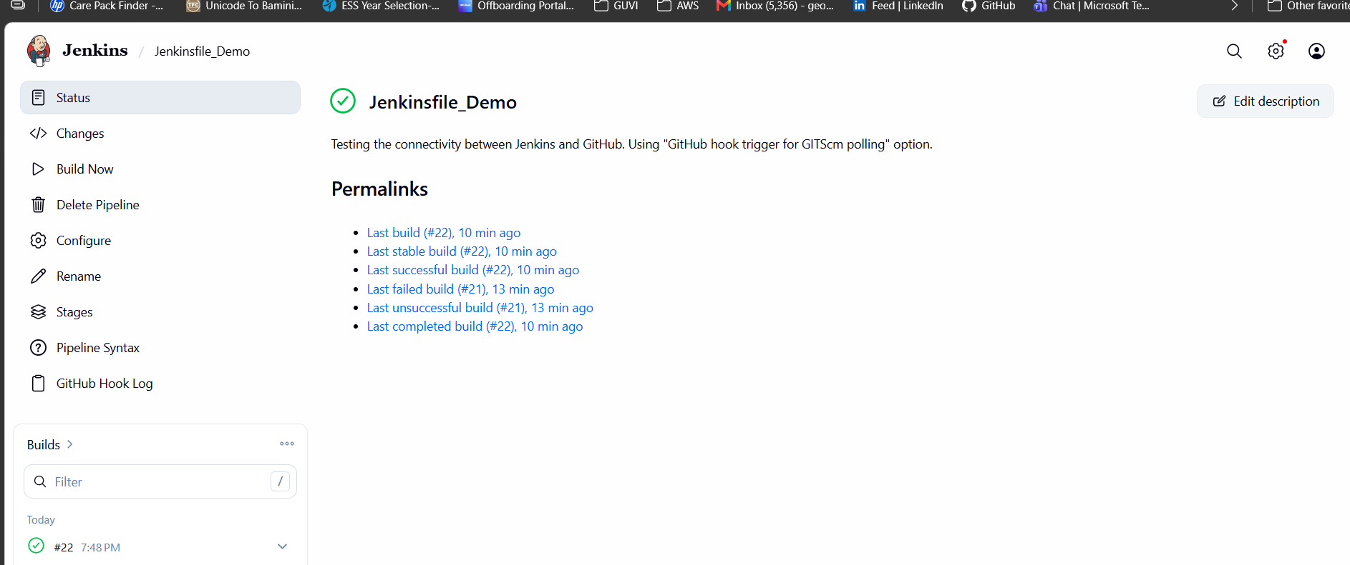
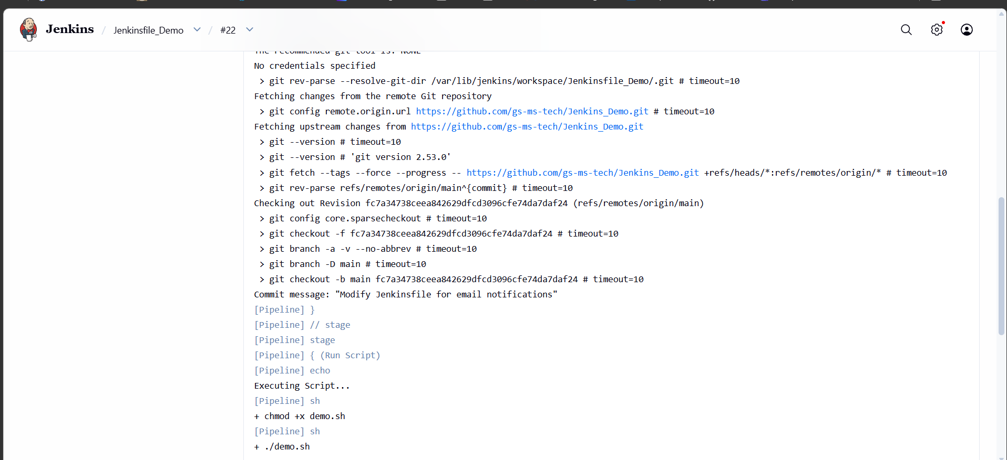
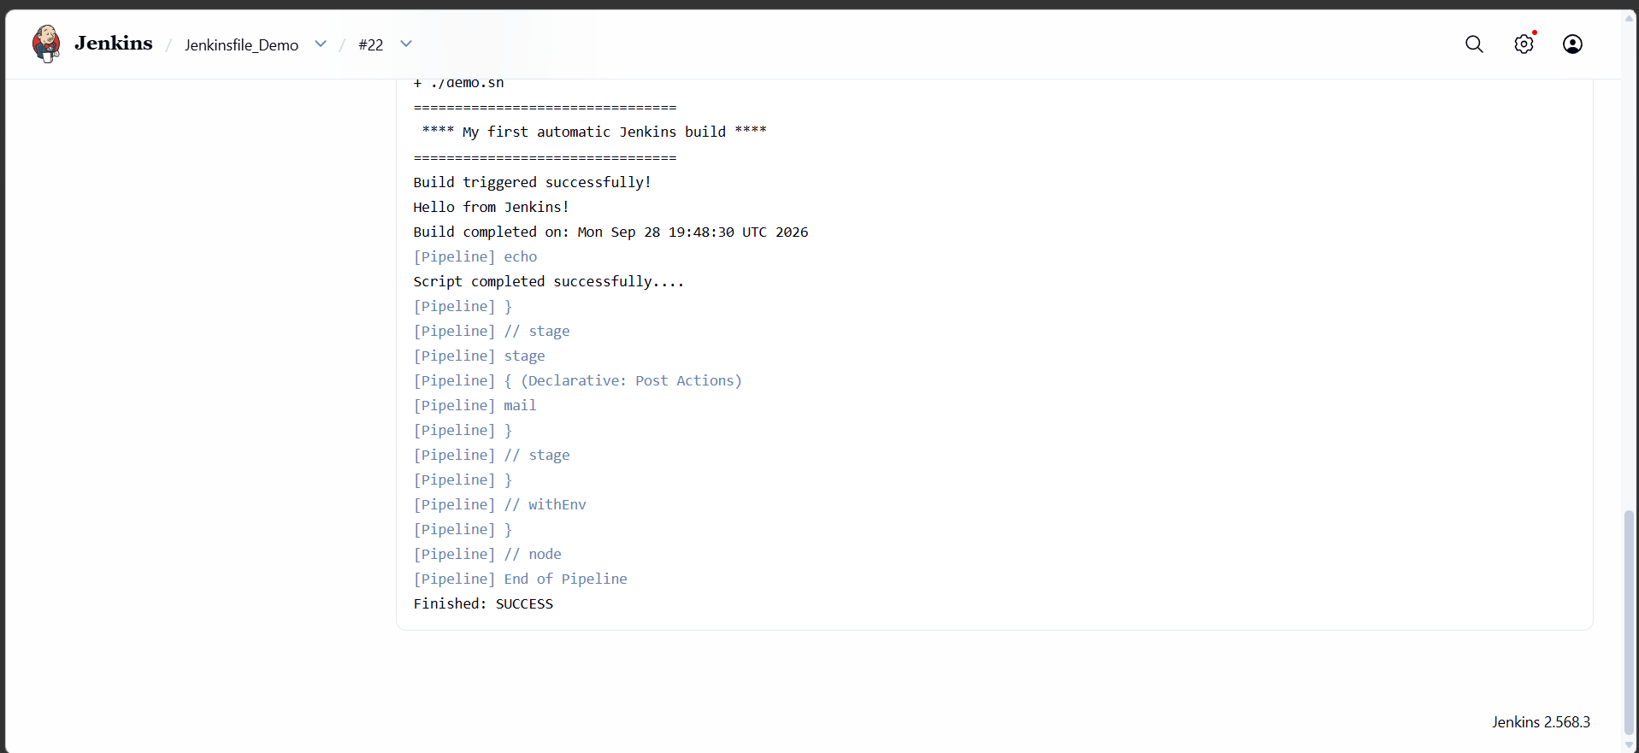

Email notification sent to mentioned recipient mail id:
